 | EUROPEAN COMMISSION  DIRECTORATE-GENERAL  INFORMATICS  Information systems Directorate

European Commission
e-TrustEx Use Case Specification: Submit Event Notification

Date: | 29/04/2016
Version: | 1.2
Authors: | Yves Adam
Revised by: | Technical Review:  Quality Review:
Approved by:
Public:
Reference Number:

TABLE OF CONTENTS
Contents
1. Use-Case Description 3
2. References 3
3. Points of Extensions 3
3.1. Points of extension mapping 3
3.2. Document Type Code 4
3.3. Party Roles 4
3.4. Document Identifier 4
3.5. Document Issue Date 4
3.6. Synchronous XSD Validation 4
3.7. Synchronous Schematron Validation 4
3.8. Synchronous Specific Validation 4
3.8.1. Synchronous SLA Validation 4
3.8.2. Other specific validation 5
3.9. Synchronous Business Specific Processing 5
3.10. Asynchronous XSD Validation 5
3.11. Asynchronous Business Rules Validation 5
3.11.1. Asynchronous Schematron Validation 5
3.11.2. Asynchronous Parent-Child Relationship Validation 5
3.11.3. Reprocessing Timeframe for Parent Document 5
3.11.4. Asynchronous Specific Validation 5
3.12. Asynchronous Business Specific Processing 5
3.12.1. Human Readable Generation 5
3.12.2. SLA Policy Validation 5
3.12.3. Other specific processing 5
3.13. Availability Notification 5
3.14. State Machine 5
3.14.1. Transition to state Approved 6
3.14.2. Transition to state Rejected 6
3.15. Dispatching 6
4. Additional Information 6

Document History

Version | Date | Comment | Modified Pages
1.000 | 14/04/2016 | Creation of this generic UC based on UC1_019 UC1_006 Configuration Notification (obsoleted) | All
1.1 | 18/04/2016 | Added party/user configuration guide in Additional Information | 6
1.2 | 29/04/2016 | Updated Additional Information section (chiricr) | 7

Use-Case Description
This Use Case describes the service that enables parties to send EventNotification document via electronic means using the e-TrustEx platform. It extends the generic use case UC1_002 Process Asynchronous Message to EventNotification document.

References
Document Title | Document Reference
UC1_002 Process Asynchronous Message | https://webgate.ec.europa.eu/CITnet/svn/ETRUSTEX/trunk/001 e-TrustEx/002 Requirements/Use Case Model/New Use Cases/UC1_002 Process Asynchronous Message.doc
Use Case eTrustex – Submit Application Response | https://webgate.ec.europa.eu/CITnet/svn/ETRUSTEX/trunk/001 e-TrustEx/002 Requirements/Use Case Model/New Use Cases/UC1_003 Submit Application Response Use Case Specification_2.0.doc
EventNotification XSD document | https://webgate.ec.europa.eu/CITnet/svn/ETRUSTEX/trunk/001 e-TrustEx/003 Architecture/001 Data Model/200 XSD/xsd/maindoc/EC-EventNotification-2.0.xsd
EventNotificationSchematron rules document | N/A
Code List Document | https://webgate.ec.europa.eu/CITnet/svn/ETRUSTEX/trunk/001 e-TrustEx/003 Architecture/001 Data Model/000 Code Tables/EC_CodeList_e-TrustEx.xls
Human Readable Template | N/A

Points of Extensions

Points of extension mapping
Point of extension (in this document) | Extended point (in Asynchronous Use Case)
Document Type Code | Point of extension 2  Point of extension 4  Point of extension 9
Party Roles | Point of extension 1
Document Identifier | Point of extension 3
Document Issue Date | Point of extension 8
Synchronous XSD Validation | Point of extension 5
Synchronous Schematron Validation | Point of extension 6
Synchronous Specific Validation | Point of extension 7
Synchronous Business Specific Processing | Point of extension 17
Asynchronous XSD Validation | Point of extension 10
Asynchronous Schematron Validation | Point of extension 11
Asynchronous Parent-Child Relationship Validation | Point of extension 12
Reprocessing Timeframe | Point of extension 16
Asynchronous Specific ValidationError: Reference source not found | Point of extension 18
Data Extraction | Point of extension 13
Asynchronous Business Specific Processing | Point of extension 14
Availability Notification | Point of extension 19
Dispatching | Point of extension 15

Document Type Code
The document type code for EventNotification is EVN and it is defined in Code List Document, under the sheet DocumentTypeCode.

Party Roles
The EventNotification document must be sent by a Party having EventPublisher Role and received by a Party having EventSubscriber Role.

Document Identifier
The document identifier can be found via the following Xpath expression:
\\EventNotification\cbc:ID

Document Issue Date
The document issue date can be found via the following Xpath expression:
\\ EventNotification \cbc:IssueDate

Synchronous XSD Validation
N/A

Synchronous Schematron Validation
N/A

Synchronous Specific Validation

Synchronous SLA Validation
N/A

Other specific validation
N/A

Synchronous Business Specific Processing
N/A

Asynchronous XSD Validation
The document must be valid according to XSD documentEventNotification.

Asynchronous Business Rules Validation

Asynchronous Schematron Validation
N/A

Asynchronous Parent-Child Relationship Validation
N/A

Reprocessing Timeframe for Parent Document
N/A

Asynchronous Specific Validation
N/A

Asynchronous Business Specific Processing

Human Readable Generation
N/A

SLA Policy Validation
N/A

Other specific processing
N/A

Availability Notification
N/A

State Machine
The following state machine shows the usual (generic) states that are Submitted, Received and Error. Beside these states some specific states are displayed in blue: Approved and Rejected.

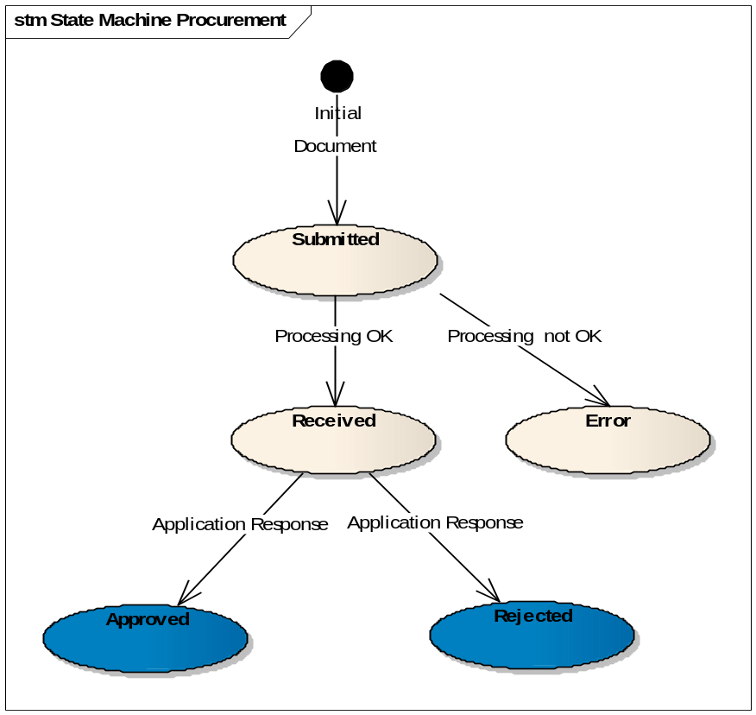
Note: it is very unlikely that any application 'approves' nor 'rejects' an EventNotification (since it does not make sense), but this possibility has nevertheless been kept in order to remain in the standard way of processing messages.

Transition to state Approved
At this point, the Use Case Submit Application Response is included.
When an application response referencing an existing EventNotification document in state received arrives in the system with a response code EVN:1 the state of the EventNotification document becomes Approved.

Transition to state Rejected
At this point, the Use Case Submit Application Response is included.
When an application response referencing an existing EventNotification document in state received arrives in the system with a response code EVN:2 the state of the EventNotification document becomes Rejected.

Dispatching
The Party or the Parties to which the EventNotification will be dispatched are defined in the configuration of eTrustEX according to:
- The type of EventNotification
- The Interchange agreement associated to the message referenced in the EventNotification
- The considered Party

Additional Information
Because the Event Notification messages will be treated by e-TrustEx just like the other messages, there needs to be some party and ICA configuration in place for these messages to pass the authorization part of the processing chain.

Party and user configuration
The parties that must be notified of events happening in e-TrustEx must be added to the table ETR_TB_EVT_NOTIF and be assigned the role EventSubscriber. The parties will be notified of events occurring in the business domain to which they belong. The EVT_TYPE column will be used to configure the type of events for which the notifications will be produced: DOC for document deletion events and CFG for configuration events (CRUD operations on parties and ICAs).

For each business domain an event notification publisher (role name EventPublisher) must be configured (e.g. ETRUSTEX). The publisher will be the sender of the Event Notification messages for events concerning the business domain to which they belong.

The configuration publisher shall authenticate with the username/password etrustex_<BD_ID>/etrustex.

ICA configuration
Each event notification subscriber must have an ICA with the publisher party belonging to the same business domain as the subscriber.

